Lucas Swanson
4/20/2025
Software Engineering Methods
Exercise 3.5
Steps for cherry pick:
- For the general steps here I am going to assume you have a repository with at least something in main.
  - If you do not, please use the following commands to get a baseline: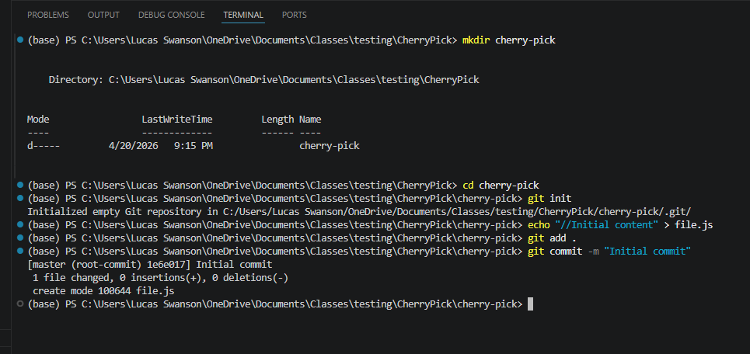
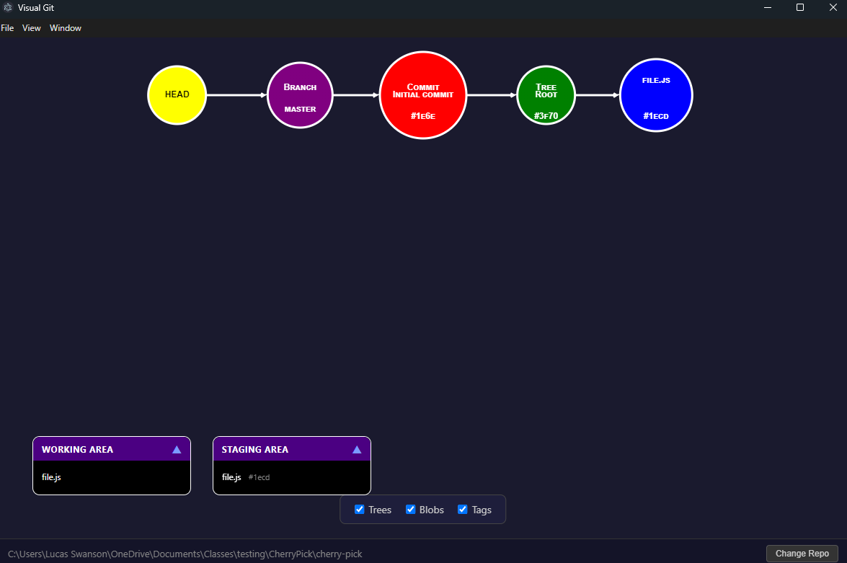
- Now that we all have a baseline repository, we begin by making a new feature branch:
  - 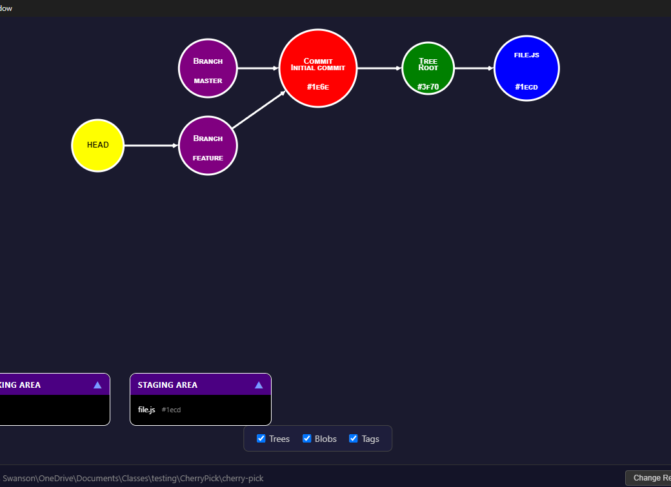
- From here we will make three features with the template “echo "//Feature A" > featureA.js” and commit each one of these one at a time until you get your feature branch to look like this:
  - 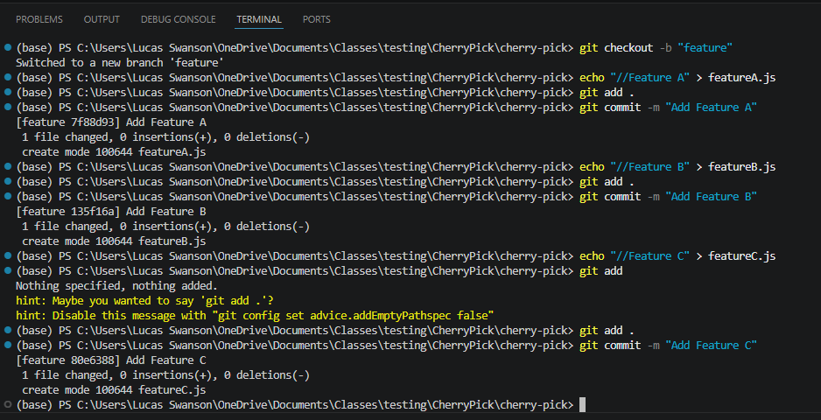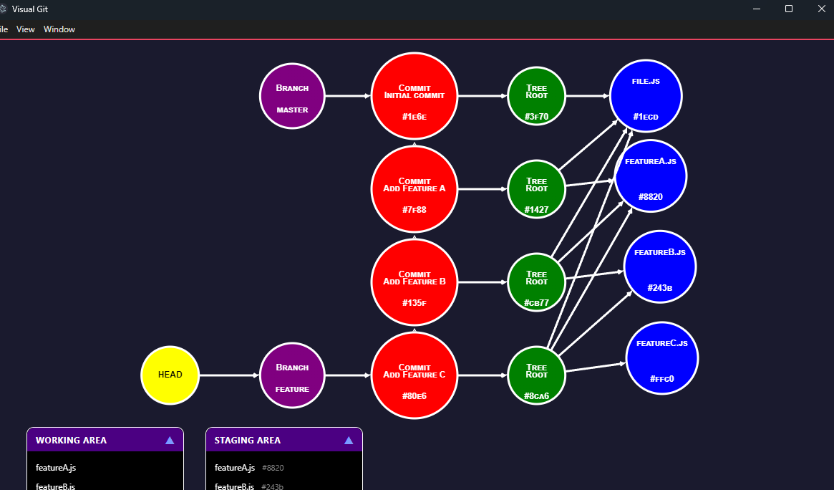
- Now we can see that we have one commit in our master branch, and three additional commits and .js files in the feature branch where we are currently working.
How the cherry pick works is when we want to bring a specific commit from the feature branch to another, we can swap to that one and select the commit hash we want to use. This requires three steps:
  - Swap to target branch you want the content on (We will select master)
  - Find the commit hash you’d like to bring over (we will select feature B)
  - Perform the command: “git cherry-pick <commit-hash>”
- Here is what your terminal will look like after doing this for Feature B onto “master”:
  - 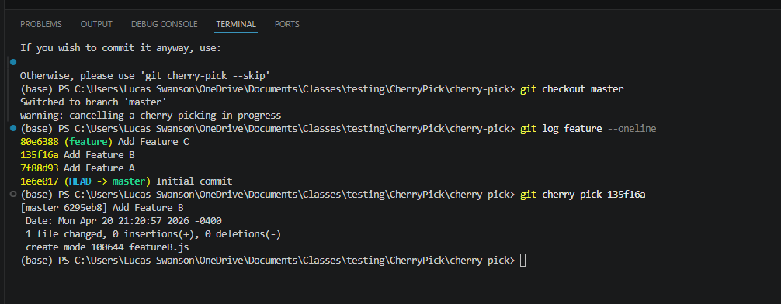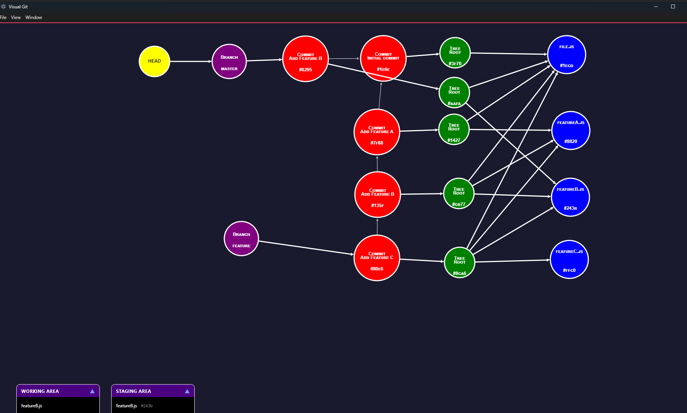
From this we can see that the local head is now pointing to our master branch, and a duplicate commit for “Add Feature B” exist right above the initial commit (both “Add Feature B” commits have a different hash ID!). This is because the cherry-pick we added is now a duplicate of the previous commit we have made.
Congratulations! You have made a cherry pick.

